1) Competitor research — 3 competitors
- Ather Energy
- TVS iQube
- Bajaj Chetak (Electric)

2) Unique Selling Points (USPs) — 4–5 strong ones
- Integrated charging network + fast charging compatibility
- Long practical range + real-world performance
- Smart connected features & app integration
- Stylish design + premium ride quality
- Attractive financing / subscription options

3) Campaign setup

a) Selected objective

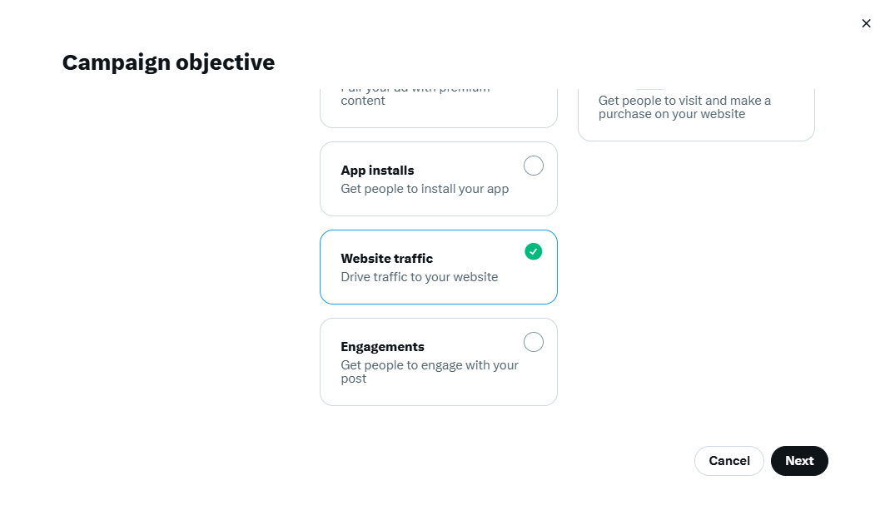

b) Budget setup

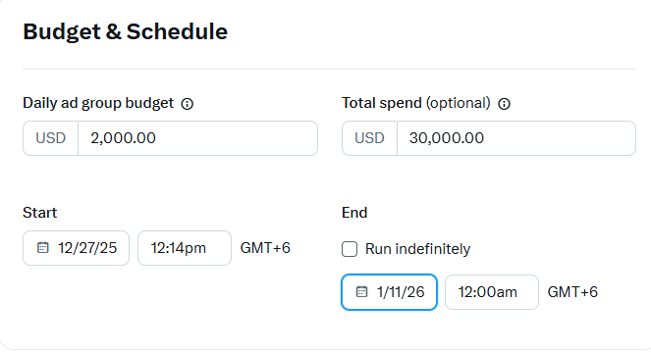

c) Audience targeting (detailed)

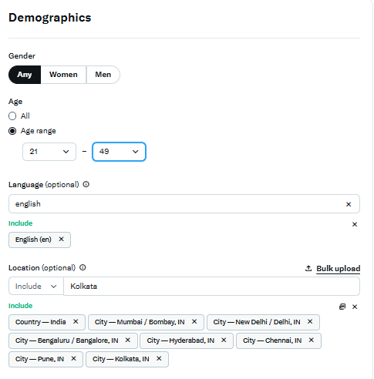

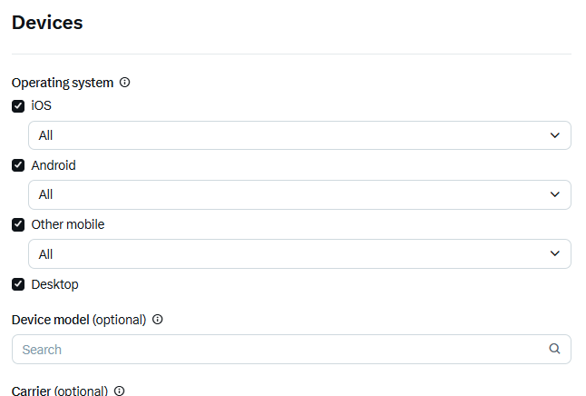

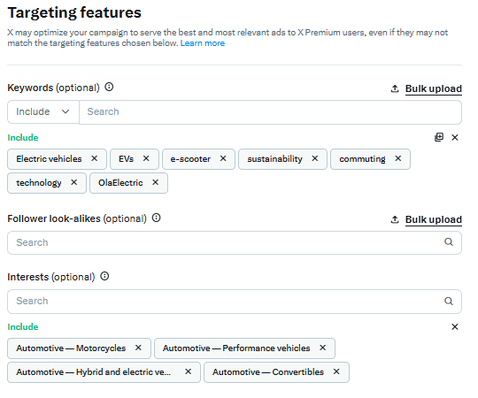

d) Ad preview (image/video + copy + CTA)

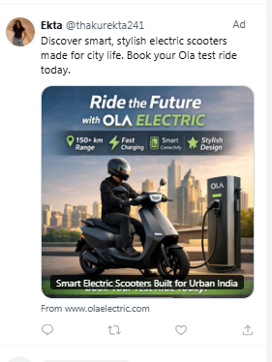

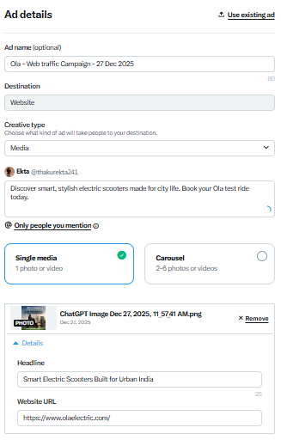

4) Estimated campaign results (targets & KPIs)

